1. **Insurance DB:-**

create database insurancedb;

use insurancedb;

CREATE TABLE PERSON(

driver_id varchar(10),

name varchar(20),

address varchar(15),

primary key(driver_id));

CREATE TABLE CAR(

regno varchar(10),

model varchar(20),

Year int,

primary key(regno));

CREATE TABLE ACCIDENT(

report_no int,

adate date,

location varchar(15),

primary key(report_no));

CREATE TABLE OWNS(

driver_id varchar(10),

regno varchar(10),

primary key(driver_id,regno),

foreign key(driver_id) references PERSON(driver_id) on delete cascade,

foreign key(regno) references CAR(regno) on delete cascade);

CREATE TABLE PARTICIPATED(

driver_id varchar(10),

regno varchar(10),

report_no int,

damage_amt float,

foreign key(driver_id,regno) references OWNS(driver_id,regno) on delete cascade,

foreign key(report_no) references ACCIDENT(report_no)on delete cascade);

show tables;

insert into PERSON values("1111","Ramu","K,S Layout");

insert into PERSON values("2222","John","Indiranagar");

insert into PERSON values("3333","Priya","Jayanagar");

insert into PERSON values("4444","Gopal","Whilefield");

insert into PERSON values("5555","Latha","Vijaynagar");

insert into CAR values("KA04Q2301","Maruthi-dx",2000);

insert into CAR values("KA05P1000","Fordicon",2000);

insert into CAR values("KA03L1234","Zen-VXI",1999);

insert into CAR values("KA03L9999","Maruthi-DX",2002);

insert into CAR values("KA01P4020","Indica-VX",2002);

insert into ACCIDENT values(12,"2002-05-01","M G Road");

insert into ACCIDENT values(200,"2002-12-10","Double Road");

insert into ACCIDENT values(300,"1999-07-23","M G Road");

insert into ACCIDENT values(25000,"2000-06-11","Residency Road");

insert into ACCIDENT values(26500,"2001-10-16","Richmond Road");

insert into OWNS values("1111","KA04Q2301");

insert into OWNS values("1111","KA05P1000");

insert into OWNS values("2222","KA03L1234");

insert into OWNS values("3333","KA03L9999");

insert into OWNS values("4444","KA01P4020");

insert into PARTICIPATED values("1111","KA04Q2301",12,20000);

insert into PARTICIPATED values("2222","KA03L1234",200,500);

insert into PARTICIPATED values("3333","KA03L9999",300,10000);

insert into PARTICIPATED values("4444","KA01P4020",25000,2375);

insert into PARTICIPATED values("2222","KA03L9999",12,10000);

update PARTICIPATED set damage_amt=25000 where report_no=12 and regno="KA03Q2301";

select count(*) from ACCIDENT where adate like "2002-__-__";

select count(a.report_no) from ACCIDENT A, PARTICIPATED P, CAR C

where A.report_no=P.report_no and P.regno=c.regno and C.model="Maruthi-DX";

**Tables :** 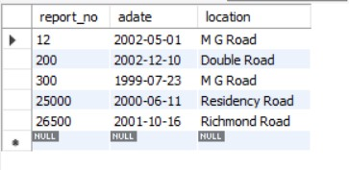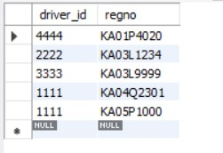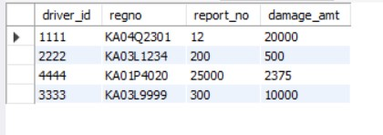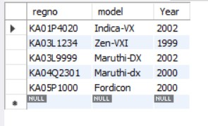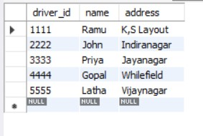

**Output:**

select count(*) from ACCIDENT where adate like "2002-__-__";

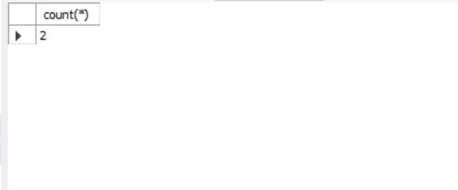

select count(a.report_no) from ACCIDENT A, PARTICIPATED P, CAR C

where A.report_no=P.report_no and P.regno=c.regno and C.model="Maruthi-DX";

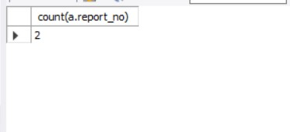

1. **Book Dealer DB:-**

create database bookdealerdb;

use bookdealerdb;

CREATE TABLE author(

author_id int,

name varchar(20),

city varchar(20),

country varchar(20),

primary key(author_id)

);

CREATE TABLE publisher(

publisher_id int,

name varchar(20),

city varchar(20),

country varchar(20),

primary key(publisher_id)

);

CREATE TABLE catalog(

book_id int,

title varchar(20),

author_id int,

publisher_id int,

category_id int,

year int,

price int,

primary key(book_id),

foreign key(author_id) references author(author_id),

foreign key(publisher_id) references publisher(publisher_id),

foreign key(category_id) references category(category_id)

);

CREATE TABLE category(

category_id int,

description varchar(30),

primary key(category_id)

);

CREATE TABLE order_details(

order_no int,

book_id int,

quantity int,

primary key(order_no),

foreign key(book_id) references catalog(book_id) on delete cascade

);

insert into author values(1001,"Teras Chan","CA","USA");

insert into author values(1002,"Stevens","Zombi","Uganda");

insert into author values(1003,"M Mano","Cair","Canada");

insert into author values(1004,"Karthik B P","New York","USA");

insert into author values(1005,"Willian Stalling","Las Vegas","USA");

insert into publisher values(1,"Pearson","New York","USA");

insert into publisher values(2,"EEE","New South Vales","USA");

insert into publisher values(3,"PHI","Delhi","India");

insert into publisher values(4,"Willey","Berlin","Germany");

insert into publisher values(5,"MGH","New York","USA");

insert into category values(1001,"Computer Science");

insert into category values(1002,"Algorithm Design");

insert into category values(1003,"Electronics");

insert into category values(1004,"Programming");

insert into category values(1005,"Operating Systems");

insert into catalog values(11,"Unix System",1001,1,1001,2000,251);

insert into catalog values(12,"Digital Signals",1002,2,1003,2001,425);

insert into catalog values(13,"Login Design",1003,3,1002,1999,225);

insert into catalog values(14,"Server Prg",1004,4,1004,2001,333);

insert into catalog values(15,"Linux OS",1005,5,1005,2003,326);

insert into catalog values(16,"C++ Bible",1005,5,1001,2000,526);

insert into catalog values(17,"Cobol Handbook",1005,4,1001,2000,658);

insert into order_details values(1,11,5);

insert into order_details values(2,12,8);

insert into order_details values(3,13,15);

insert into order_details values(4,14,22);

insert into order_details values(5,15,3);

insert into order_details values(6,17,10);

select * from author;

select * from publisher;

select * from category;

select * from catalog;

select * from order_details;

use bookdealerdb;

/*--details of the authors having aleast 2 books along with year of publish is greater than 2000*/

select * from author where author_id in(select author_id from catalog where year>=2000 group by author_id having count(author_id)>=2);

/*--author names with max sales of books*/

select a.name from author a, catalog c, order_details o where a.author_id=c.author_id and c.book_id=o.book_id and o.quantity=(select max(quantity) from order_details);

/*--increase the price of book by 10% of a specified publisher(eg:- publisher_id=5)*/

update catalog set price=(price+price*0.1) where publisher_id=5;

**Tables:**

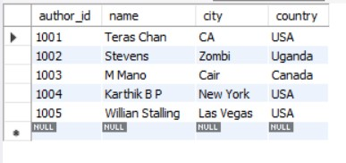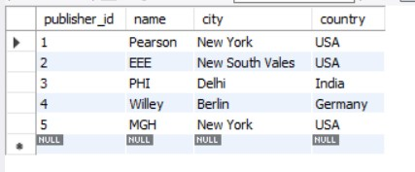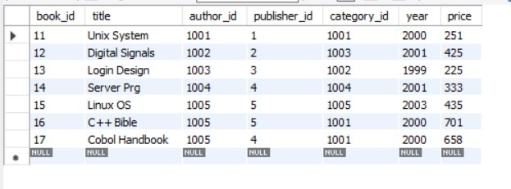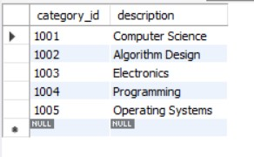

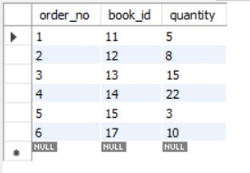

**Output:**

select * from author where author_id in(select author_id from catalog where year>=2000 group by author_id having count(author_id)>=2);

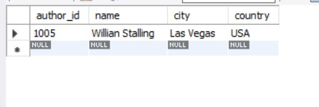

select a.name from author a, catalog c, order_details o where a.author_id=c.author_id and c.book_id=o.book_id and o.quantity=(select max(quantity) from order_details);

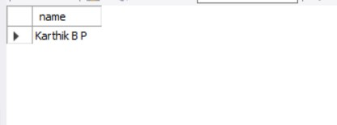

1. **Order DB:**

create database orderdb;

use orderdb;

create table CUSTOMER(

cust_no int,

cname varchar(20),

city varchar(20),

primary key(cust_no)

);

create table ordertb(

order_no int,

odate date,

cust_no int,

order_amount int,

primary key(order_no),

foreign key(cust_no) references CUSTOMER(cust_no)

);

create table item(

item_no int,

unit_price int,

primary key(item_no)

);

create table ORDER_ITEM(

order_no int,

item_no int,

qty int,

foreign key(order_no) references ordertb(order_no),

foreign key(item_no) references item(item_no),

primary key(order_no,item_no)

);

create table warehouse(

warehouse_no int,

city varchar(20),

primary key(warehouse_no)

);

create table shipment(

order_no int,

warehouse_no int,

odate date,

foreign key(order_no) references ordertb(order_no),

foreign key(warehouse_no) references warehouse(warehouse_no),

primary key(order_no,warehouse_no)

);

insert into customer values(771,"Pushpa K","Bangalore");

insert into customer values(772,"Suman","Mumbai");

insert into customer values(773,"Sourav","Calicut");

insert into customer values(774,"Laila","Hyderabad");

insert into customer values(775,"Faizal","Bangalore");

insert into ordertb values(111,"2002-01-22",771,18000);

update ordertb set order_no=111 where order_no="111";

insert into ordertb values(112,"2002-07-30",774,6000);

insert into ordertb values(113,"2003-04-03",775,9000);

insert into ordertb values(114,"2003-11-03",775,29000);

insert into ordertb values(115,"2002-12-10",773,29000);

insert into ordertb values(116,"2004-08-19",772,56000);

insert into ordertb values(117,"2004-09-10",771,20000);

insert into ordertb values(118,"2004-11-20",775,29000);

insert into ordertb values(119,"2005-02-13",774,29000);

insert into ordertb values(120,"2005-10-13",775,29000);

insert into item values(5001,503);

insert into item values(5002,750);

insert into item values(5003,150);

insert into item values(5004,600);

insert into item values(5005,890);

insert into order_item values(111,5001,50);

insert into order_item values(112,5003,20);

insert into order_item values(113,5002,50);

insert into order_item values(114,5005,60);

insert into order_item values(115,5004,90);

insert into order_item values(116,5001,10);

insert into order_item values(117,5003,80);

insert into order_item values(118,5005,50);

insert into order_item values(119,5002,10);

insert into order_item values(120,5004,45);

insert into warehouse values(1,"Delhi");

insert into warehouse values(2,"Mumbai");

insert into warehouse values(3,"Chennai");

insert into warehouse values(4,"Bangalore");

insert into warehouse values(5,"Bangalore");

insert into warehouse values(6,"Delhi");

insert into warehouse values(7,"Mumbai");

insert into warehouse values(8,"Chennai");

insert into warehouse values(9,"Delhi");

insert into warehouse values(10,"Bangalore");

insert into shipment values(111,1,"2002-02-10");

insert into shipment values(112,5,"2002-09-10");

insert into shipment values(113,8,"2003-02-10");

insert into shipment values(114,3,"2003-12-10");

insert into shipment values(115,9,"2004-01-19");

insert into shipment values(116,1,"2004-09-20");

insert into shipment values(117,5,"2004-09-10");

insert into shipment values(118,7,"2004-11-30");

insert into shipment values(119,7,"2005-04-30");

insert into shipment values(120,6,"2005-12-21");

use orderdb;

select * from customer;

select * from ordertb;

select * from item;

select * from order_item;

select * from warehouse;

select * from shipment;

use orderdb;

/*Question 1*/

select c.cname,count(o.order_no),avg(o.order_amount) from customer c

inner join ordertb o

on c.cust_no=o.cust_no

group by c.cust_no;

/*Question 2*/

select o.order_no,w.city from ordertb o

inner join shipment s

on o.order_no=s.order_no

inner join warehouse w

on s.warehouse_no=w.warehouse_no

where w.city="Delhi" /*This can be added to specify the city to be viewed*/

order by w.city;

/*Question 3*/

delete from order_item where order_no=120;

**Tables:**

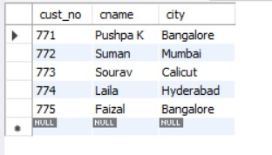

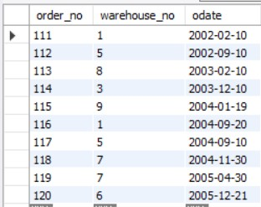

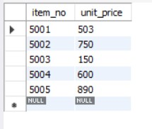

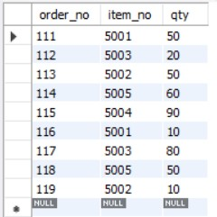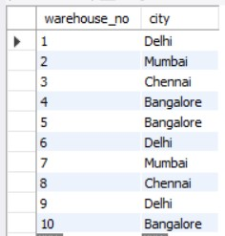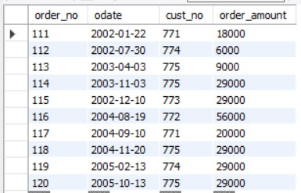

**Outputs:**

select c.cname,count(o.order_no),avg(o.order_amount) from customer c

inner join ordertb o

on c.cust_no=o.cust_no

group by c.cust_no;

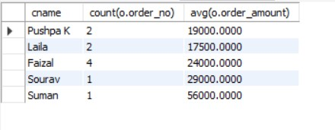

select o.order_no,w.city from ordertb o

inner join shipment s

on o.order_no=s.order_no

inner join warehouse w

on s.warehouse_no=w.warehouse_no

where w.city="Delhi" /*This can be added to specify the city to be viewed*/

order by w.city;

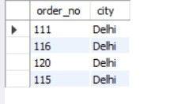

1. **Banking DB:**

create database bankingdb;

use bankingdb;

CREATE TABLE branch

( branch_name VARCHAR(15),

branch_city VARCHAR(15),

assets float,

PRIMARY KEY(branch_name)

);

CREATE TABLE account

( accno INT,

branch_name VARCHAR(15),

balance float,

PRIMARY KEY(accno),

FOREIGN KEY(branch_name) REFERENCES branch(branch_name)ON DELETE CASCADE

);

CREATE TABLE customer

( customer_name VARCHAR(15),

customer_street VARCHAR(15),

customer_city VARCHAR(15),

PRIMARY KEY(customer_name)

);

CREATE TABLE loan

( loan_number INT,

branch_name VARCHAR(15),

amount float,

PRIMARY KEY(loan_number),

FOREIGN KEY(branch_name) REFERENCES branch(branch_name)

);

CREATE TABLE depositor

( customer_name VARCHAR(15),

accno INTEGER,

PRIMARY KEY(customer_name, accno),

FOREIGN KEY(customer_name) REFERENCES customer(customer_name),

FOREIGN KEY(accno) REFERENCES account(accno)

);

CREATE TABLE borrower

( customer_name VARCHAR(15),

loan_number INT,

PRIMARY KEY(customer_name, loan_number),

FOREIGN KEY(customer_name) REFERENCES customer(customer_name),

FOREIGN KEY(loan_number) REFERENCES loan(loan_number)

);

INSERT INTO BRANCH VALUES

("SBI PD NAGAR", "BANGALORE", 200000),

("SBI RS NAGAR", "BANGALORE" ,500000),

("SBI JAYANAGAR" ,"CHENNAI",60000),

("SBI VIJAYNAGAR" ,"DELHI", 870000),

("SBI GBROAD" ,"DELHI", 550000);

INSERT INTO ACCOUNT VALUES

(1000,"SBI PD NAGAR",5000),

(1001,"SBI RS NAGAR",5000),

(1002,"SBI JAYANAGAR",5000),

(1003,"SBI VIJAYNAGAR",40000),

(1004,"SBI GBROAD" ,4000);

INSERT INTO ACCOUNT VALUES

(1005,"SBI GBROAD",5500),

(1006,"SBI VIJAYNAGAR",2500);

INSERT INTO CUSTOMER VALUES

("RAM","BSTREET 45","BANGALORE"),

("SHYAM","BSTREET 46","BANGALORE"),

("RAJAT","CSTREET 55","CHENNAI"),

("AAKASH","DSTREET 65","DELHI"),

("SURESH","DSTREET 66","DELHI");

INSERT INTO DEPOSITOR VALUES

("RAM",1000),

("SHYAM",1001),

("RAJAT",1002),

("AAKASH",1003),

("SURESH",1004);

INSERT INTO DEPOSITOR VALUES

("SURESH",1005),

("AAKASH",1006);

INSERT INTO LOAN VALUES

(10,"SBI PD NAGAR",10000),

(11,"SBI RS NAGAR",20000),

(12,"SBI JAYANAGAR",30000),

(13,"SBI VIJAYNAGAR",40000),

(14,"SBI GBROAD" ,50000);

INSERT INTO BORROWER VALUES

("RAM",10),

("SHYAM",11),

("RAJAT",12),

("AAKASH",13),

("SURESH",14);

/*QUES 1*/

SELECT customer_name

FROM depositor d,account a

WHERE d.accno=a.accno

/*AND a.branch_name='SBI VIJAYNAGAR'*//*THIS CAN BE ADDED TO SPECIFY BRANCH NAME*/

GROUP BY d.customer_name

HAVING COUNT(d.customer_name)>=2;

/*QUES 2*/

SELECT d.customer_name FROM account a,branch b,depositor d

WHERE b.branch_name=a.branch_name AND

a.accno=d.accno AND

b.branch_city='CHENNAI'

GROUP BY d.customer_name

HAVING COUNT(distinct b.branch_name)=(

SELECT COUNT(branch_name)

FROM branch

WHERE branch_city='CHENNAI');

/*QUES 3*/

DELETE FROM account WHERE branch_name IN(SELECT branch_name FROM branch WHERE branch_city='CHENNAI');

**Tables:**

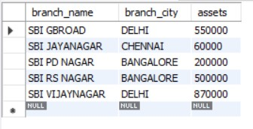

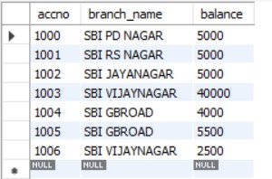

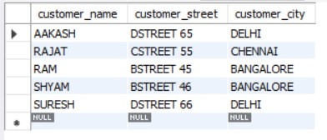

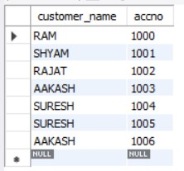

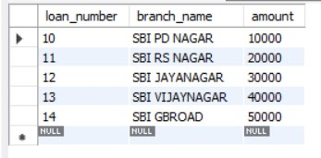

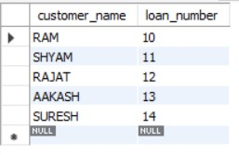

**Outputs:**

SELECT customer_name

FROM depositor d,account a

WHERE d.accno=a.accno

/*AND a.branch_name='SBI VIJAYNAGAR'*/ /*THIS CAN BE ADDED TO SPECIFY BRANCH NAME*/

GROUP BY d.customer_name

HAVING COUNT(d.customer_name)>=2;

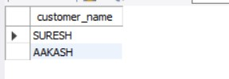

SELECT d.customer_name FROM account a,branch b,depositor d

WHERE b.branch_name=a.branch_name AND

a.accno=d.accno AND

b.branch_city='CHENNAI'

GROUP BY d.customer_name

HAVING COUNT(distinct b.branch_name)=(

SELECT COUNT(branch_name)

FROM branch

WHERE branch_city='CHENNAI');

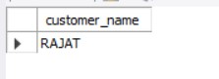

1. **Student Enrollment DB:-**

CREATE DATABASE STUDENT_ENROLLMENT;

USE STUDENT_ENROLLMENT;

CREATE TABLE STUDENT(

REGNO VARCHAR(10),

NAME VARCHAR(20),

MAJOR VARCHAR(5),

BDATE DATE,

PRIMARY KEY(REGNO)

);

CREATE TABLE COURSE(

COURSE_NO INT,

CNAME VARCHAR(5),

DEPT VARCHAR(5),

PRIMARY KEY(COURSE_NO)

);

CREATE TABLE ENROLL(

REGNO VARCHAR(10),

COURSE_NO INT,

MARKS INT,

SEM INT,

PRIMARY KEY(REGNO, COURSE_NO),

FOREIGN KEY(REGNO) REFERENCES STUDENT(REGNO),

FOREIGN KEY(COURSE_NO) REFERENCES COURSE(COURSE_NO)

);

CREATE TABLE BOOK_ADOPTION(

COURSE_NO INT,

SEM INT,

BOOK_ISBN INT,

FOREIGN KEY(COURSE_NO) REFERENCES COURSE(COURSE_NO),

FOREIGN KEY(BOOK_ISBN) REFERENCES TEXTBOOK(BOOK_ISBN)

);

CREATE TABLE TEXTBOOK(

BOOK_ISBN INT,

BOOKTITLE VARCHAR(50),

PUBLISHER VARCHAR(20),

AUTHOR VARCHAR(20),

PRIMARY KEY(BOOK_ISBN)

);

INSERT INTO STUDENT VALUES

("CS01","RAM","DS","1986-03-12"),

("IS02","SMITH","USP","1987-12-21"),

("EC03","AHMED","SNS","1985-04-17"),

("CS03","SNEHA","DBMS","1987-01-01"),

("TC05","AKHILA","EC","1986-10-06");

INSERT INTO COURSE VALUES

(11,"DS","CS"),

(22,"USP","IS"),

(33,"SNS","EC"),

(44,"DBMS","CS"),

(55,"EC","TC");

INSERT INTO ENROLL VALUES

("CS01",11,4,85),

("IS02",22,6,80),

("EC03",33,2,80),

("CS03",44,6,75),

("TC05",55,2,8);

INSERT INTO TEXTBOOK VALUES

(1,"DS AND C","PRINCETON","PADMA REDDY"),

(2,"FUNDAMENTALS OF C","PRINCETON","GODSE"),

(3,"FUNDAMENTALS OF DBMS","PRINCETON","NAVATHE"),

(4,"SQL","PRINCETON","FOLEY"),

(5,"ELECTRONIC CIRCUITS","TMH","ELMASRI"),

(6,"ADV UNIX PROG","TMH","STEVENS");

INSERT INTO BOOK_ADOPTION VALUES

(11,4,1),

(11,4,2),

(44,6,3),

(44,6,4),

(55,2,5),

(22,6,6);

DELETE FROM BOOK_ADOPTION

WHERE BOOK_ISBN=7;

DELETE FROM TEXTBOOK

WHERE BOOK_ISBN=7;

/*QUES 1*/

INSERT INTO TEXTBOOK VALUES(7,"JAVA THE COMPLETE REFERENCE","ORACLE PRESS","HERBERT SCHILDT");

INSERT INTO BOOK_ADOPTION VALUES(55,2,7);

/*QUES 2*/

SELECT C.COURSE_NO,BA.BOOK_ISBN, TB.BOOKTITLE FROM COURSE C, BOOK_ADOPTION BA, TEXTBOOK TB

WHERE C.COURSE_NO=BA.COURSE_NO AND BA.BOOK_ISBN=TB.BOOK_ISBN AND C.DEPT="CS"

AND 2<=(SELECT COUNT(BOOK_ISBN) FROM BOOK_ADOPTION B

WHERE C.COURSE_NO=B.COURSE_NO)

ORDER BY TB.BOOKTITLE;

/*QUES 3*/

SELECT DISTINCT C.DEPT FROM COURSE C

INNER JOIN BOOK_ADOPTION BA

ON BA.COURSE_NO=C.COURSE_NO

INNER JOIN TEXTBOOK TB

ON TB.BOOK_ISBN=BA.BOOK_ISBN

WHERE TB.PUBLISHER="PRINCETON";

**Tables:**

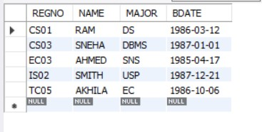

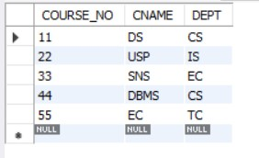

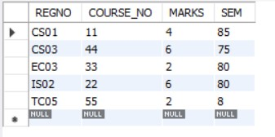

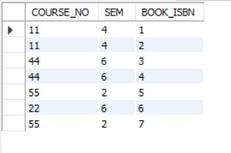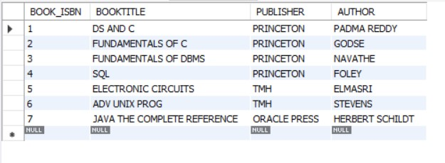

**Outputs:**

SELECT DISTINCT C.DEPT FROM COURSE C

INNER JOIN BOOK_ADOPTION BA

ON BA.COURSE_NO=C.COURSE_NO

INNER JOIN TEXTBOOK TB

ON TB.BOOK_ISBN=BA.BOOK_ISBN

WHERE TB.PUBLISHER="PRINCETON";

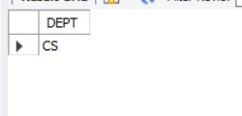

SELECT C.COURSE_NO,BA.BOOK_ISBN, TB.BOOKTITLE FROM COURSE C, BOOK_ADOPTION BA, TEXTBOOK TB

WHERE C.COURSE_NO=BA.COURSE_NO AND BA.BOOK_ISBN=TB.BOOK_ISBN AND C.DEPT="CS"

AND 2<=(SELECT COUNT(BOOK_ISBN) FROM BOOK_ADOPTION B

WHERE C.COURSE_NO=B.COURSE_NO)

ORDER BY TB.BOOKTITLE;

